**OUR HOME IS THE WORLD**

**E- TWINNING PROJESİ**

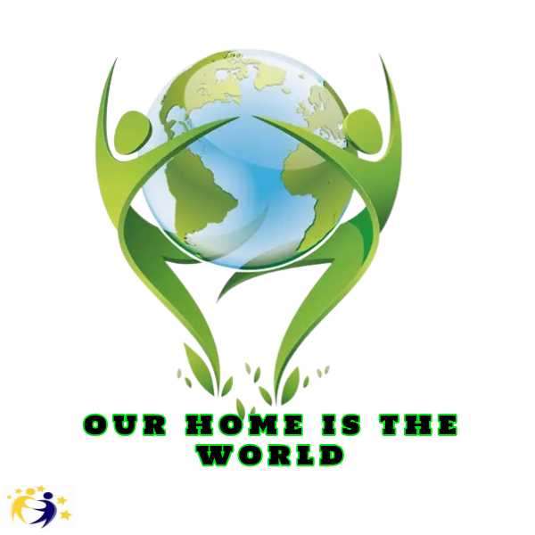

 Okulumuz İngilizce  öğretmeni Sevil SERDAR  Öğrencilerimiz ile  bir eTwinning Projesine başladılar.

MEB'in de desteklediği eTwinning Platformunda bir araya gelen öğretmenler Our Home is the World (Evimiz Dünya) İsimli projeye başladılar. Proje Türkiye'nin 9 farklı İlinden ,4 Diğer Ülkelerden 13 öğretmenin 55 öğrencinin katılımıyla başladı.

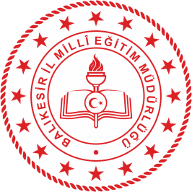

**eTwinning Project Template**

|  |  |
| --- | --- |
| Project name | Our Home is the World |
| Project Purpose:  (Express in one sentence)  BRIEF DESCRIPTION | It aims to raise awareness of students about sustainability and consumption habits. |
| Project Goals:  (Be clear about the competencies and skills you hope your students will gain through this project  ) | -To raise individuals who are socially conscious and have a developed sense of responsibility.  -To enable our students to throw away the energy they have with games,  -Creating different learning environments with extracurricular activities  -Making learning through games permanent  -Contributing to the social development of students  - To increase the self-confidence of children  -To ensure the development of students' digital skills  -Contributing to the professional development of teachers |
| Project Process:  (Give your opinion on sharing responsibilities. Establish an approximate timetable for activities, express how often you will work with your partner, describe how you want to get students involved) | Our project is planned as 3 months. A maximum of 2 and a maximum of 10 students can participate in the project. Regular meetings are planned to be held every month during the project. Task sharing and timetable will be clearly stated in the project plan, by sharing the tasks equally with all partners in the project. |
| Project Outputs:  EXPECTED RESULTS  (Final product and collaborative work, if you plan to reveal it, state it here. | At the end of the project, students acquire correct consumption habits.  They have nature consciousness.  They learn to save.  -The individual's vocabulary will increase.  The self-confidence of the student who actively participates in the process develops.  -Responsibility awareness is formed, the effort to fulfill the given task develops.  -Students learn to trust themselves and others by producing products collaboratively. |

**PROJE KURUCU ORTAKLARI:**

**Alev YILMAZ** – **Şehit Abdurrahim Çakır Ortaokulu Koçarlı /AYDIN/TÜRKİYE**

**Nancy ABUJABER- Khalda Secondary School Khalda/ AMMAN /JORDON**

Proje Ortakları:

|  |  |
| --- | --- |
| Lulia BUCATARU | Scola Gimnaziala ,,Vasile Conta”, Lasi  Laşi/ LASI/ROMANİA |
| Nadia Travaglione | ICS “G.B. Bosco Lucarelli” di Benevento  Benevento(Bn) /CAMPANİ/ITALY |
| **Margherita DE LUCA** | ICS “G.B. Bosco Lucarelli” di Benevento  Benevento(Bn) /CAMPANİ/ ITALY |
| [Sevil SERDAR](https://school-education.ec.europa.eu/tr/user/65994) | Manisa Güzel Sanatlar Lisesi  Yunusemre/ MANİSA /TÜRKİYE |
| **[Mehmet](https://school-education.ec.europa.eu/tr/networking/people/n009qv08)** Ali GEDİKLİ | Düzköy Nazım Kayhan Mesleki ve Teknik Anadolu Lisesi  Düzköy/ TRABZON/ TÜRKİYE |
| Yasemin BEREKETOĞLU | Kenan Oltan Anadolu Lisesi  Maçka/ TRABZON/ TÜRKİYE |
| [**Eda**](https://school-education.ec.europa.eu/tr/user/647681) ÖZTÜRK | Van Atatürk Anadolu Lisesi  İpekyolu /VAN/ TÜRKİYE |
| Fatma ÇAKIR | Adnan Menderes Anadolu Lisesi  Karşıyaka/İZMİR/TÜRKİYE |
| **[Mine](https://school-education.ec.europa.eu/tr/networking/people/n00b1xwg)** DAĞ | İskenderun Mehmet Akif Ersoy Ortaokulu  İskenderun/HATAY /TÜRKİYE |
|  |  |
| **[Gülçe SEZEN](https://school-education.ec.europa.eu/tr/user/566637)** | Karabiga Mustafa Kemal Ortaokulu  Biga /ÇANAKKALE/TÜRKİYE |
| Hilal ÖZÇELİK SAKALLI | Güzeloba İmam Hatip Ortaokulu  ANTALYA/TÜRKİYE |
| **[Demet](https://school-education.ec.europa.eu/tr/user/163527)** KOŞUN | Toki Korubaşı Ortaokulu  Ereğli/ ZONGULDAK/TÜRKİYE |
|  |  |